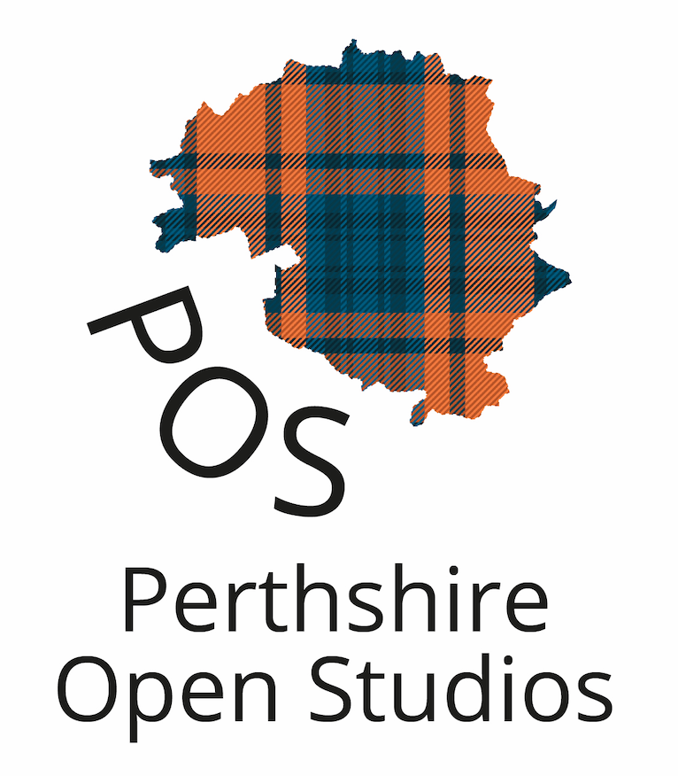

Press release: 29 June 2023
For immediate release

New Annual Summer Show Will Feature Seventy Perthshire Artists and Makers
- Big Tree Country also deserves to be famed for its creative community
- Creative Trail aims to make Perthshire a year-round arts destination
The first ever POS Summer Show will showcase work by more than 70 artists and makers from across Perth and Kinross.
The event, at Birnam Arts from 1-16 July, is part of a wider drive by POS (Perthshire Open Studios) to make the region a year-round arts destination.
As well as the Summer Show it has recently set up the Perthshire Creative Trail featuring 15 galleries and 32 artists’ studios (including 17 in the Perth Creative Exchange) allowing people to meet artists, visit galleries, discover walks and distilleries whatever the time of year.
In September there will be the ever-popular Perthshire Open Studios Festival.
Heather Budge-Reid, Chair of POS, said: “Perthshire is special. It’s famous for the big trees and big views, but it also deserves to be known for its large and vibrant creative community. So we are creating more and better opportunities for visitors to discover Perthshire’s arts and crafts.
“The Summer Show will be a chance to see work of all kinds from over 70 of our members in the wonderful rural setting of Birnam and Dunkeld.
“And the Creative Trail lets visitors meet artists and see their work at all times of year, rather than having to wait for special events like the exhibition or the annual open studios festival.”
Among those taking part in the Summer Show are ceramicists Ceri White and Jacquie Clark, painters Jonathan Mitchell and Hilary Law, jewellery designers Roberta Pederzoli and Inez Jenkins, glass artists John Anderson, Lorna Radbourne, Lynn Shilp and Lesley Garside and willow artists Rachel Kirk and June McEwan.
Angela Thomson, a member of the team who has been liaising with artists, said: “One of the great things about the exhibition is that it gives POS members a chance to show their creativity in a modern, professional gallery as well as drawing art lovers out to the gorgeous countryside.”
The exhibition and trail came about following a consultation which showed that artists were keen to continue to hold an open studio festival but also wanted an all year-round attraction and more support for the galleries which sell their work.
- See https://perthshireopenstudios.com.
-Ends-

Notes for editors
About POS
POS aims to contribute to strengthening the economic, cultural, tourism and heritage environments throughout Perthshire by: Supporting Perthshire creatives
- Increasing the number of residents and visitors who get a sense of place through travelling around Perthshire and ‘Seeing the Inspiration.’
- Strengthening artists’ marketing skills
- Increasing cooperation and support between individual artists and Perthshire-focused organisations.
The objectives of POS are to:
- Organise and promote an all-year-round Perthshire Creative Trail.
- Organise and promote an open studios festival in Perthshire that supports economies of scale.
- Develop marketing/promotional skills of POS members and their access to the benefits of membership.
- Endeavour to work in coordination with other organisations with similar goals.
Perthshire Open Studios (POS) has been running for over 13 years. Entirely volunteer run, the open studios festival event across Perthshire attracts visitors and residents, supporting economic and cultural growth as well as cultural benefits. In 2021, 143 venues and 198 solo artists participated in POS. Previous research shows that for every pound spent on organising the festival each year, £15 is spent in Perthshire.
POS is now focusing on three events a year - an all year-round creative trail, a September open studio festival and a summer exhibition. In addition to developing training events for artist looking to spread the word about their art. It was also agreed that it was important to work with other artist organisations in Perthshire.
The trail is made possible with the support of Perth and Kinross Council, UNESCO City of Craft (Perth), VisitScotland, Perth Creative Exchange, Growbiz, Perthshire Artisans, and the team at The Quair and is organised by Perthshire Open Studios.
For media information contact Matthew Shelley at SFPR on 07786 704299 or at Matthew@ScottishfestivalsPR.org.
Perthshire Open Studios CIC. Company number: SC498236. Registered office: Artisanand, 13-15 Bank St, Aberfeldy, PH15 2BB

