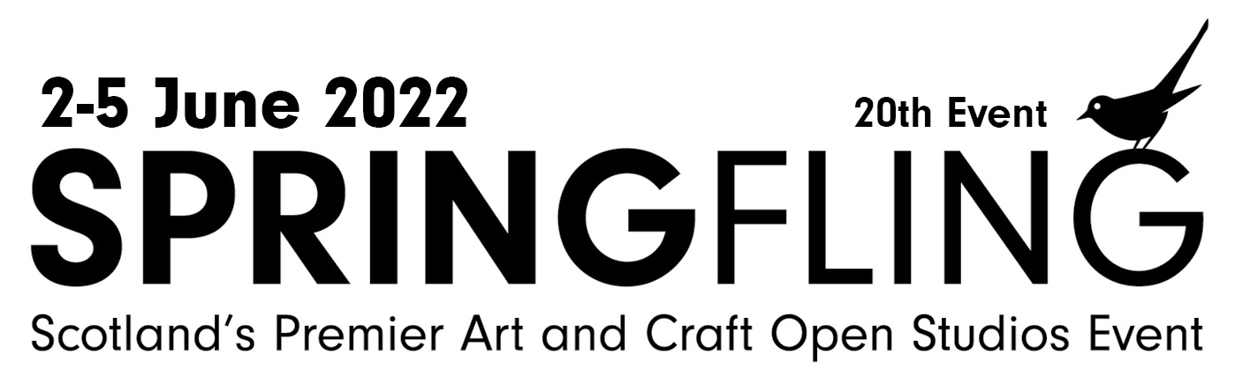

Press Release: 5 April, 2022
Art originals – first Spring Flingers launch programme for 20th year
- Event set up in the wake of foot and mouth will help rebuild after COVID
- Discover nearly 100 studios plus three exhibitions
Artists and makers from the first Spring Fling got together to launch the programme for the 20th annual open studios weekend.
The event, set up in the aftermath of the foot and mouth epidemic, now hopes to make a significant contribution in the drive to rebuild after the COVID pandemic.
Spring Fling, which takes place over the Queen’s Platinum Jubilee Bank Holiday weekend from 2-5 June, will see 96 participants all across Dumfries and Galloway, throw open their doors to welcome the public.
Sixteen of 2003 originals will be taking part in 2022. Nine of them (plus one of the first organisers) met up at the Gracefield Arts Centre, in Dumfries, and spoke about what has made the event so special.
Hannah McAndrew, of potters Fitch and McAndrew from Corsock, said: I cannot believe I am old enough to have been around for 20 Spring Flings but it seems I must be. It's rather lovely to have been there at the beginning and to still be making my living making pots all these years later when the event itself is going from strength to strength.
“Spring Fling is also hugely important for the region. We have such talented people here, complete masters of their crafts and it is fabulous that Dumfries and Galloway has become known for this intense fountain of creativity.”
Jo Gallant, a textile artist from Mossdale, said: “I feel very proud to have been involved with Spring Fling since the beginning, though when the idea was first presented I was sceptical, as other open studios events I had tried had not been particularly successful. It soon became clear though that this was something different.
“It’s now a significant event in my work calendar. It has become an important event in the region with visitors, both local and from further away looking forward to it each year.”
Ruth Elizabeth Jones, a ceramicist from Moniaive, said: “I took part in the first Spring Fling when I had not long moved to Scotland and I’m thrilled to be still taking part 20 years later.
“The event has helped to give D&G a reputation as a good region to be an artist or maker, the event has attracted a loyal following both local and further afield and helped artists and makers develop a good audience for their work. It has also put D&G on the creative map.”
Lizzie Farey, willow artist from Kirkcudbright, said: “Having Spring Fling as part of my creative practice for 20 years has been amazing. Artists and makers from other parts of the UK were very envious of what we had. The professionalism and consistent high standards set by Spring Fling meant it became a flagship for other regions to imitate.”
Adam Booth, architectural metalworker and sculptor from Kirkpatrick Durham: “An open studios event is great for this region. If you consider the population of Dumfries and Galloway and look at the number of high-quality national and international makers and artists living here it is quite remarkable and it is attracting more all the time.
“It shows what a vibrant and inclusive region we live in. Spring Fling is a great chance for people to see these threads and celebrate the region as a whole.”
Bella Green, visual artist and jewellery maker from Lockerbie, said: “I am glad to be still taking part and grateful to all who have kept it going and thriving for so long. It has been a constant support and resource for information both professionally and personally. Long may it continue - as art and artists are as essential as ever in this troubled world of ours.”
Sheena McMaster, jewellery maker and silversmith from Kirkcudbright: “Having the opportunity from the early days on the Spring Fling to engage and meet clients from all over Scotland has been wonderful. For many of us in the arts the pandemic meant that this was curtailed. This being the 20th makes it even more special.”
Clare Melinsky, illustrator and original printmaker from Thornhill, said: “Spring Fling has been the best support for the local artistic community. We are scattered about in distant parts of Dumfries and Galloway, and Spring Fling brings us together, not physically, but in one big network.
“The original event was set at a high standard, which has been maintained over the years. Originally I exhibited in the studio of one friend or another, so we supported each other. But the most recent events have been at my own home.”
William Spurway, visual artist from Corsock who will be exhibiting in Dumfries, said: “For the first Spring Fling we opened our tiny cottage, clearing everything into the bedroom and hanging paintings and prints in the two other rooms and the hall. Now I have a wonderful studio as part of an artists’ co-operative at Solway House.
“For me, Spring Fling represents a coming together of a vibrant community of artists and makers all working towards the same goal, to make each year unique, to showcase our region as a whole, alongside the high calibre of work that is professionally produced here. Spring Fling has become a fundamental part of my practice. I look forward to the next 20 years of its life.”
Spring Fling was set up by Dumfries and Galloway Council Visual Arts Development Officer Jane McArthur and Crafts Development Officer Clare Hanna.
Clare Hanna, who now works for the Holywood Trust, said: “There had been attempts at an open studio event before foot and mouth hit the region and they hadn’t been successful. So the pressure was on, we knew we had one chance and we had to get it right.
“I think the fact that artists and makers were involved in the development and helped shape Spring Fling has been a big part of its success and longevity.”
and helped shape Spring Fling has been a big part of its success and longevity.”
This year’s event will mark a return to being a physical first event after two years in which it was largely or completely digital.
This year’s programme includes:
- Biscuit Factory Exhibition: 14 May to 24 July at the Biscuit Factory, Newcastle Upon Tyne. Twenty past and present Spring Flingers fly the flag for the art and craft of south west Scotland at the UK’s largest art, craft and design gallery.
- Spring Fling at 20: 28 May to 2 July at Gracefield Arts Centre in Dumfries. An exhibition featuring work by more than 40 past and present participants.
- Modern Makers: 14 May to 25 June at Gracefield Arts Centre in Dumfries. An exhibition celebrating the Modern Makers programme which allows young people to learn traditional craft techniques.
- Spring Fling Open Studios Weekend: 2-5 June across Dumfries and Galloway. Close to 100 specially selected artists and makers open their studios to the public.
Visitors will be able to follow six colour-coded routes taking them round studios in different parts of the region and some studios will have special evening openings and offer other attractions like demonstrations. As ever there will also be bus tours round selected studios.
There will also be an illustrated online talk by artist Amy Whiten of Recoat, about the highly successful Rural Mural project. And for those who can't attend Spring Fling in person, there are virtual studios to explore on the website.
Chris Bridgman, Upland Project Manager, who is organising this year’s event, said: “It’s a real tribute to Spring Fling that so many of those who took part in the first event will be involved in the 20th.
“Back in 2003 it harnessed the strength of our creative community to help the region rebuild in the aftermath of foot and mouth. Since then it has grown and developed into an important feature in Scotland’s annual arts and cultural calendar, attracting thousands of visitors and generating millions of pounds for the economy.
“After two difficult years we hope that this specially extended 4-day Spring Fling, which takes place over the jubilee weekend, will encourage visitors to rediscover Dumfries and Galloway – and make a significant contribution to its recovery from COVID.”
- Brochures can be ordered from the Spring Fling website and a downloadable version will be available in April. For further details visit www.spring-fling.co.uk.
- The organisers will ensure that all government COVID-19 guidance is followed so visitors and participants can take part in a safe Spring Fling.
-Ends-
Notes for editors

About Spring Fling
- Spring Fling made its name as Scotland’s premier visual art and contemporary craft open studios event covering all Dumfries and Galloway, South West Scotland. It is the flagship annual event of Upland CIC.
- For further details visit www.spring-fling.co.uk or contact info@spring-fling.co.uk
- Spring Fling is pleased to once again have the support from Dumfries & Galloway Council as one of the region’s Signature Events.
About Upland
Upland CIC (Community Interest Company) supports artists and makers based in, and with connections to, the region. It delivers, events, training, networking, support and opportunities as part of a year-round programme to benefit the region, its artists, communities and economy. Upland CIC runs the annual Spring Fling contemporary visual art and craft open studios weekend in Dumfries and Galloway. It will work closely with other arts bodies in the region to further-strengthen the sector. Upland is based at Gracefield Arts Centre in Dumfries and exists to:
- produce and deliver festivals, events, and experimental projects of the highest quality
- nurture an environment where artistic excellence thrives and grows
- inspire and educate a wide range of audiences, customers and clients to understand, celebrate, be actively engaged in and supportive of visual art and craft practice
- raise the profile of visual artists and makers locally, nationally and internationally fulfilling a crucial role in the culture and tourism of Dumfries and Galloway
- build strategic partnerships at regional, national and international level
- maintain a financially sound and adaptively resilient organisation
- work to the benefit the local economy and the sustainability of local communities.
Its funders are Creative Scotland, D&G Council, The Holywood Trust, The Barfill Trust.
About Creative Scotland
Creative Scotland is the public body that supports the arts, screen and creative industries across all parts of Scotland on behalf of everyone who lives, works or visits here. We enable people and organisations to work in and experience the arts, screen and creative industries in Scotland by helping others to develop great ideas and bring them to life. We distribute funding provided by the Scottish Government and the National Lottery. For further information about Creative Scotland please visit www.creativescotland.com. Follow us @creativescots and www.facebook.com/CreativeScotland.
For media information contact Matthew Shelley on 07786 704299 or at Matthew@ScottishFestivalsPR.Org or call Upland on 01387 213 218.
